**GROUP 56 – BOLT**



**GROUP MEMBERS**

**Mahama Abdul Hafiz - 10881447**

**Woolley Joseph Paul - 10921657**

**Owusu Abankwah Benedict - 10918803**

**Agbeshie Dodzie - 10907407**

**TABLE OF CONTENT**

**CHAPTER 1...……………………………………………………………………………………2**

Abstract**……………………………………………………………………………………………2**

Background**………………………………………………………………………………………..2**

Overview of the system**…………………………………………………………………………...3**

Aims of the project**………………………………………………………………………………..3**

Objectives of the project**…………………………………………………………………………..3**

**CHAPTER 2 LITERATURE REVIEW………….……………………………………………4**

**CHAPTER 3 ANALYSIS……………………………………….…………………….………..11**

**CHAPTER 4 SYSTEM DESIGN…………………………………………………….………..15**

**CHAPTER 5 CONCLUSION ………………………………………………………….……..18**

**APPENDIX - PROPOSAL………………………………………………………………..…....19**

Introduction**………………………………………………………………………………………19**

Justification**………………………………………………………………………………………19**

Description of proposed system **…………………………………………………………………20**

Aims of the project**……………………………………………………………………………….20**

Objectives of the project**…………………………………………………………………………20**

Scope and Limitation**…………………………………………………………………………….21**

Project plan**………………………………………………………………………………………22**

Gannt chart**……………………………………………………………………………………….23**

Key activities**…………………………………………………………………………………….24**

**FYNEST PHARMACY MANAGEMENT SYSTEM**

**REPORT OF THE PROJECT**

**CHAPTER 1**

**ABSTRACT**

Pharmacy Management System – Admin and pharmacist use this system to manage pharmacy in a systematic way. Medicines are easy identify by pharmacist through the search button base on the customers condition or illness which will display the medicine or the product for treatment. This system is developed by the good views of doctors and advice through the complains of lost stock or unidentified product expiry date. Illness such as fever or cough is mostly affected by the respiratory system of human being and most pharmacist don’t find it easy to identify the right medicine for these symptoms. Pharmacy is the medical facility to help or serve the people of certain population in their health conditions. Before the introduction of this system, pharmacy uses manual system to manage their medicine stock. It also delays the assistant of the pharmacist to check the expiry date twice a week for a particular medicine in storage and doing this to avoid selling it to a customer to cause damage. To overcome this stressful work done, the pharmacist just needs to log into the system and notification of expired medicines are displayed. For purchasing the order, pharmacist can generate it automatically from the system when the medicine stock that out of stock.

**BACKGROUND**

Pharmacy management system is the process managing medicine stock and customer information as well as all the products stock in the inventory of the pharmacy. The main duty of pharmacist is the maintenance of good and subsequent implication of taking care of patient. The system is mainly based on the industry of pharmacy management is a medical technology industry.

The domain of this project is information communication technology in healthcare. For the introduction of information communication technology, the system developer takes the opportunity to create a system which will help the pharmacist to take account of a stock products and selecting medicine by the use of computer program. The organization who benefits from this system is the pharmacy care centers or stores.

The system also does buy, selling and selling process of medicines. The selling is done by the sales personnel or the pharmacist. Information or alert are giving out by the system to the pharmacist by the condition of a stock or product.

The modules involve are the Users module, Medicine type module, Medicine category module, Supplier list module, Sales module, Receiving module, Expired product list module, Customer module and Inventory module.

**OVERVIEW OF THE SYSTEM**

The FYNEST pharmacy management system is design and created to manage the sales and inventory, monitoring of available stock of the well-known medicine store in the country. This system is modified to help us in tracking expired product and also gives us notifications of the expiring date of the stock. And this will also check the amount of stock that a medicine product, that is expired and imputed into the system to deduct the number of stocks that is already for inventory monitoring and sales product available. The system is categorized by the list of medicines and types of medicine such as capsule, liquid, tablet, injection, etc. with this feature which helps the cashier or the sales manager to easily search and identifies the details of a requested medicine from which the customer is looking for, for example if a customer is looking for a 102g of Vitamin C +Zink, Selen medicine(Prolife) which is categorized in the group of medicine use for Healthy living but in this case, the pharmacy doesn’t have this product at that time, and this will help the pharmacist to search for another product in details to what the customer is looking for which will filter a product in the same similarity as said by the customer.

**JUSTIFICATION**

This is the reasons of developing the system to help reduce the work load of pharmacist and also helps to manage the day-to-day activities of the pharmacy. The reasons are stated below’

1. In recent times, selecting of medicine for customers takes time, so customer or patient must wait for some time.

1. Secondly, pharmacist has to check manually for the expiry date and the number of decrease medicine stock which are about to finish. So, this system helps in providing alert messages to warn the pharmacist about the medicine stock.
2. Finally, pharmacist will not find it difficult to make analyses of product purchased mostly by the customers in that area so as to supply more in the inventory stock list page for customer order and sales.

**AIMS OF THE PROJECT**

The aim of this project is to examine the challenges faced by various pharmacies and how to develop a web base system that will provide solutions to the problems or challenges faced by the pharmacies. There are strategies put in place to resolve the problems at hand and give it a supporting guide line to promote the health care services.

**OBJECTIVES OF THE PROJECT**

The main objective of developing this system is to help in assisting pharmacist and other factors in our health care or environment. These factors or objectives are listed below.

1. To provide a well secure system software to help in retrieval of information
2. To provide stock exchange between the pharmacist and the suppliers.
3. To help in making decisions for the pharmacy.
4. To provide a systematic medicine inventory in stocking product
5. To manage the sales and report of the products in stock.

**CHAPTER 2**

**LITERATURE REVIEW AND RESEARCH METHODOLOGIES**

This chapter introduce us to the types of methodologies and the script of languages that were used to develop the system. The research was based on the SSADM and Multi view Approach which brings us many ideas from people and the corporate body of the health service. The introduction of **Data protection laws** has been served as a security to protect the system from threat and spams. Other indications such as the DBMS and PHP, JAVASCRIPT, and ORACLE languages are used as a scripting language to help in adjusting or developing the system. The justification of all the method stated above will be introduced at the end of every point.

**STRUCTURED SYSTEM ANALYSIS AND DESIGN METHOD (SSADM)**

SSADM is a widely used computer application development method for developing computer programs. The SSADM is the most required system methodologies used by the European countries for developing government computing projects. The methodology has a public domain and main specified by the British standard BS7738. SSADM helps in splitting application development project into several Modules, stages, steps, and tasks and provides a framework in managing the project.

**OBJECTIVES OR IMPORTANCE OF SSADM**

* It helps to make more effective use of inexperienced and experienced development staff to manage the system
* It improves the project management and the control of the system.
* The SSADM enables support by the computer-based tools such as the computer-aided software engineering systems.
* It helps to develop better and quality system.
* It helps to establish a good framework of communication between the participants and the developer.

**MULTI VIEW**

Multiview is an approach to system analysis and design and is accompanied by the view of specification of independent tasks from people. It focuses mainly on various perspectives of organizational goals and aims to further by integrating the system according to the views and objectives of the people working within the organization. Approach such as human oriented, technical and economical are used by Multiview approach in developing both small scale and large-scale applications systems.

**SOFT APPROACH**

The soft approach method focuses on organizational process modeling, which may be utilized for both general problem resolution and change management. To put it another way, the soft approach method is used to structure complex and viable modifications between the users, development team, and stakeholders. Everyone proposes different suggestions, and the right ones will be evaluated for the system's development.

**HARD APPROACH**

The hard approach method focuses on the real-world issues of a system, using an objective or yet-to-be-achieved system goal as a method for gathering system requirements. The system's yet-to-be-achieved goal is being designed. Finally, the hard approach can be contrasted with the research that was done on using system ideas to solve unstructured problems.

**RAPID APPLICATION DEVELOPMENT MODEL (RAD)**

The model is based on the prototype and iterative development that comes with no specific planning. The rapid application development focuses on gathering the information of customer requirements through the workshop or focus group, by testing the prototype of customers using iterative concepts. RAD is one of the most used methodology since customers feels relaxed and released from pressure since the waterfall model is one of the stressful approaches to encounter issues because the process takes too long and doesn’t feel comfortable with the end results. The RAD favor the uses of minimal planning of rapid prototyping. All feedbacks are taken into consideration and more changes are made by the original prototype and given back to the public. The functional models are developed in parallel as prototypes and are integrated to make the complete of product for faster product delivery to customer.

**JUSTIFICATION**

After going through series of analysis for the best methodology for my system, I have been convinced mainly on the use of **Multi view approach methodology** which is the best suited analysis to meet the necessary requirement in developing the web application system. Multiview analysis is more focused on the ideas of the stakeholders and the people which comes with various perspectives of the organization’s goals. Since the system is based on human health, human oriented are being considered for faster delivery of product to customers and the aims and objectives from the customers and workers within the organization are will considered for the Pharmacy management system. The Multiview approach is also flexible since all the views and requirements of the participants are well structured and meet for faster operations and delivery.

**DATA PROTECTION PRINCIPLES**

The data protection principles are the set of rules and regulations governing individual information being used or collected for private work. The rights of the individual privacy are taken into consideration of how companies and organizations access or uses their information.

* **ACCOUNTABILTY**

This refers to the way in which the organization must congest to the usage of the data principle and rules applied to every information and comply to them.

* **INFORMATION SECURITY**

Personal information taken from others must be kept secured and saved.

* **DATA MINIMIZATION**

All information being collected from any source must meet the exact process needed by the organization and not subjected to non-relevant information implemented into the project or assignment.

* **TRANSPARENCY, LAWFULNESS AND FAIRNESS**

There must be a set of legal rights for collecting the information from the client’s data. All the information must be gathered legally. Clients should be referenced and also get notified about their data collected or used.

**HOW THE DATA PROTECTION PRINCIPLE WILL BE APPLIED TO THE SYSTEM**

There are various data protection principles which governs the development of the web application system. The below principles are the ones to be applied to the system.

* The information of every client will be kept save and customer will feel secure about their data being inputted into our system.
* Customer will be notified about their information being used or collected for future reference and backup.

**RESEARCH ON SCRIPTING LANGUAGES AND DEVELOPMENT TOOLS**

**HTML 5**

HTML or Hyper Text Makeup Language is the main language for creating web pages and other web information that can be displayed on the web browser. The HTML is written in the form of elements consisting of tags enclosed in angle brackets like (<html>) in the web page content. HTML tags is the commonly used in creating pairs such (<h1>) and (</h1>) and some tags represents empty elements and are unpaired. Example of this tag is the image tag <img>. The purpose of the web browser is to read the HTML documents and compose them to visible web pages. The HTML allows images and object to show on the web page and serve as an interactive form. The browser doesn’t display the HTML tag but use it to interpret the content of the page. It provides a secure created structure documents by denoting structural semantics for text such as lists, headings and links.

**PHP**

PHP is a powerful server-side scripting language for creating dynamic websites. Php is perfectly suited for developing web site and it can be embedded directly into HTML code. The PHP programing language can do all sort of things and evaluate all forms of data sent from the web browser, build custom web content to serve the browser. It can be used on many web servers and can operate almost on every operating system. PHP is widely-used, free and efficient alternative to competitors such as Microsoft’s ASP. The php code is interpreted by the web server with a PHP processor module, which generates the resulting web page.

**JAVASCRIPT**

JavaScript (Js) is a dynamic computer programing language. It most used in web browser to allow clients-side script to interacts with the user, control the browser and alter the documents content that is displayed. JavaScript is a prototype scripting language which has a dynamic capability and a class function. It makes Web pages and web browsers more interactive with the user and also used in developing many programing software such as the java applications for mobile devices.

**JUSTIFICATION**

In justifying the suited programing language for the proposed system, Personal home page (PHP) is the powerful scripting language that interact with all the programing language and operate very well with most web servers. PHP can do all things on the web browser and can be embedded into HTML and interact directly with MYSQL and JAVASCRIPT. Another scripting language that can assist the system to operate faster and become simpler in operation is JAVASCRIPT. The language makes the system very effective and comes with speed, compatibility and capable of performing each task in the system.

**ANALYSIS AND RESEARCH ON DATABASE MANAGEMENT SYSTEMS (DBMS)**

The DBMS is a database software which is mainly used in storing, saving, securing and retrieving of personal information on a computer system. The software helps the user to perform a specific task by creating their own database to manage their firm or businesses. The DBMS which is properly research is MYSQL, EXEL and SQLITE.

**MYSQL**

MySQL is the most popular open-source database that helps in enabling the cost-effective delivery of reliable, scalable web-based and embedded database applications. It mostly used in connection of PHP language script to create a powerful web server application. The server is run by the help of application software’s such XAMP, WAMP and ORACLE. It is easily to be used and performs extremely powerful and it is the ideal database solution for websites.

**MICROSOFT EXEL**

Excel is a software that is created by Microsoft for keeping of record and storing of data with the used of spreadsheet which is use to organize the functions, numbers and formulars. Excel analysis is used by most businesses to perform their financial operations and keeping of personal records. Excel is normally used in data management, data entry, accounting, programing and financial modeling.

**SQLITE**

SQLite is a software that grant access for user in managing their database system. The SQLite operates on its own without the use of external servers. The software runs on a serverless, self-contained and has an impressive feature to perform its operations. The SQLite doesn’t depend on operating system to perform it functions and has the ability to run on devices such as media player, mobile devices etc. It operates more faster on every device without slowing down operations.

**JUSTIFICATION**

The best choosing database system after my research analysis will be MYSQL which is the best suited database management system for meeting the required functions of the system. It is the most used DBMS due to it security features and also has a higher performance rate as compared to the SQLite and MS Excel.

**DEVELOPMENT TOOLS BASED ON RESEARCH**

The breakdown of the project is based on the main technology used in developing the system. Technologies in current times helps in improving life cycle and development of new tools to support human living.

* **TECHNOLOGIES**
* PHP
* MYSQL
* JAVASCRIPT
* HTML
* CSS
* **FRONT END**
* INTERFACE
* LOGIN
* HOME PAGE
* USER INFORMATION
* **BACK END**
* MYSQL DATABASE
* PHP FUNCTIONS
* **SERVER**
* WAMPSERVER 3.0.0
* **OPERATING SYSTEM**
* WINDOWS XP, WINDOWS 7, WINDOWS 8, WINDOWS 10, WINDOWS 11

**CONLUSION**

In this chapter, I have explained all the methodologies, DBMS, Scripting languages and data protection principles. It’s justified to the right tools for developing the system. The introduction of the Analysis of the system will be listed in the next chapter iii.

**CHAPTER 3**

**ANALYSIS AND REQUIREMENT GATHERING TECHNIQUES**

This chapter is well documented for the introduction of the functions and non-functions of the system. The analysis is based on the illustration of various activity diagrams to demonstrated the activities that run through the system in terms of operation and performance. The use case diagram and the rich picture also explains the human activities within the system.

**QUESTIONAIRE AND INTERVIEWS**

The questionnaire method is the suited method to gather information for the operations of the pharmacy management system. This method is done by asking questions from various doctors, pharmacist and customers through interviews. The method is very reliable for the system developer to easily create and the ideas from various people gives more vibrant information through the questioning and interviews. The information gathered will be used and evaluated for the development of the system.

**ADVANTAGES**

* It helps to explain and understand the research subjects of retrieving information.
* Interviews and questions are based on open minded that help to collect data.

**OBSERVATION METHOD**

This method involves the physical examining of how previous operations were done by the pharmacy and made more research on them to help in developing the new system for the pharmacy. The developer will be able to get their prototype or ideas in creating the system.

**IDENTIFICATION OF FUNCTIONAL REQUIREMENT**

* **LOGIN PAGE**
* This page of the system is where all the users will submit their details or credentials to access the data in the pharmacy management system.
* **HOME PAGE**
* The section or area where users will come across after a successful log into the system by default.
* **MEDICINE LIST PAGE**
* This page is where all the available medicines at the pharmacy listed and it managed only by the admin.
* **MEDICINE CATEGORY PAGE**
* The page is where all the kinds of medicine listed in categories and is manage by the system users.
* **MEDICINE TYPE PAGE**
* This page contains all the product type listed in the system.
* **SUPPLIER LIST PAGE**
* The page where the admin manages the pharmacy’s suppliers.
* **RECEIVING PAGE**
* The page where the admin input all the received medicinal product delivered by the pharmacy supplier. This feature help to update the availability of stock product in the pharmacy.
* **CUSTOMER PAGE**
* The page that displays all the listed customers who makes purchases at the pharmacy.
* **SALES PAGE**
* This page shows the admin on the number of sales transactions done.
* **INVENTORY PAGE**
* This page is where the admin or management monitor their number of stock product left at the pharmacy.
* **EXPIRED PRODUCT LIST**
* The page that shows or display the confirmed stock that has expired which helps in deduction from the stock available in certain product in the system.
* **USER LIST**
* This page is managed by the admin and the sales of the pharmacy and also the inventory system users list.

**IDENTIFICATION OF NON-FUNCTIONAL REQUIREMENT**

* **PERFORMANCE**

The performance of this web application is based on any type of operating system to perform its functions to the best point. The functions or feature doesn’t require a high processor or RAM to start operation or working but requires an internet browser and a good network connectivity to perform very fast.

* **SECURITY**

The system provides adequate security to the users where every user must have a registered credentials before he or she can get access into the system.

* **USABILITY**

This web application is very simple for every user to use and also convenient for beginners.

* **CAPACITY**

The system is not limited to the number of sales and inventory stocked by the admin for daily or weekly operations.

* **RESPONSIVENESS**

The system is faster and quicker to respond to operations within some seconds.

* **PORTABILITY**

The system can be run on every machine or location you may find yourself since it is a web-based application and it hosted on the internet.

* **RELIABILITY**

The system will perform better due the connectivity of internet and admin and pharmacist can work fully to perform their daily transactions to customers.

* **EFFICIENCY**

The system will manage the day-to-day activity for every period of time as compared to the old ways of operations.

* **SCALABILITY**

The system will be capable to perform very well on the number of tasks given to work without affecting the performance.

**APPROPRIATE DIAGRAMS FOR THE SYSTEM**

**RICH PICTURE**

The rich picture shows the human activities that goes on in the system and always work through processes using simple diagram to illustrate it. The diagram is mostly related to the markets and sales of teams to interact with each other to develop marketing strategies. A rich picture is not only used to understand the current system but to understand the relationship between the roles taken by stakeholders and issues that persist in the company or organization.

**FIG. 1 RICH PICTURE**

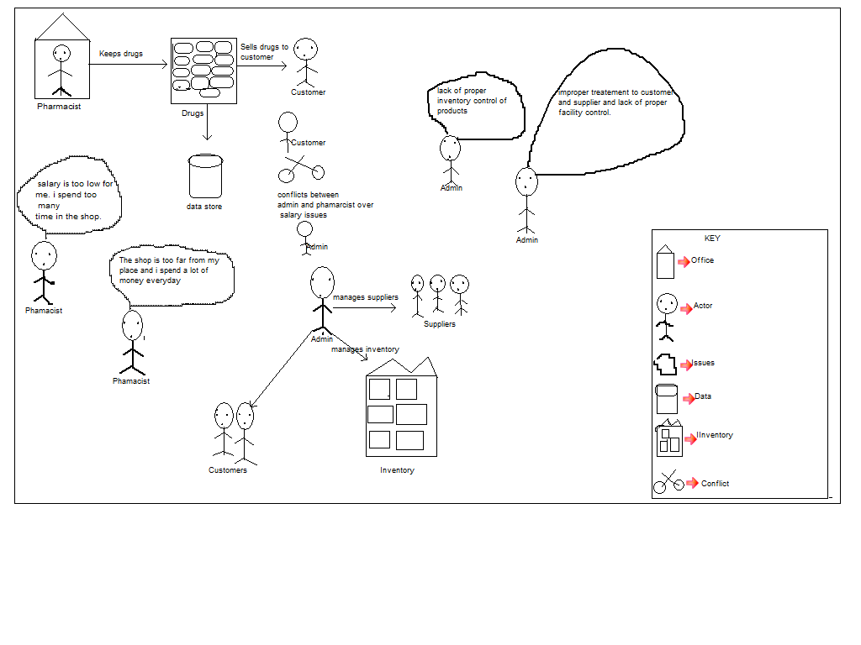

**USE CASE DIAGRAM**

This diagram is a graphical way of interactions between the elements of the pharmacy management system. It represents the methodology used in the system analysis to organize and clarify system requirements of the management system. The main actors of the system are stated in the diagram such as Admin, Pharmacist/ Shopkeeper, System User and Customers.

**FIG. 2 USE CASE DIAGRAM**

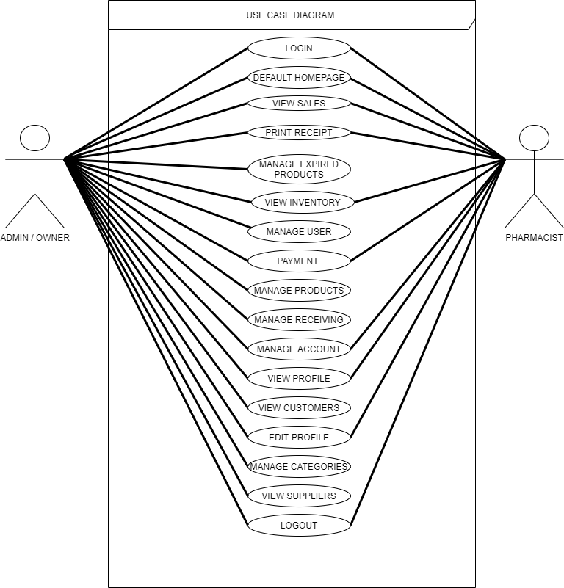

**CHAPTER 4**

**DESIGN OF THE SYSTEM**

This chapter is based on the how the system is design by the use of various diagrams such as Class diagram, Entity relation diagram and other behavioral diagrams which talks about the activities that goes on within the system such as Activity diagram, use case diagram and the right approach is choosing for the system with justification and snippets of some useful programing codes and screenshots of the system.

**STRUCTURAL MODEL**

**CLASS DIAGRAM**

Class diagram is a model representative of the tables relating to the database of the system and how the class objects are presented with their respective attributes and operations. The class diagram is shown below

**FIG. 3 CLASS DIAGRAM**

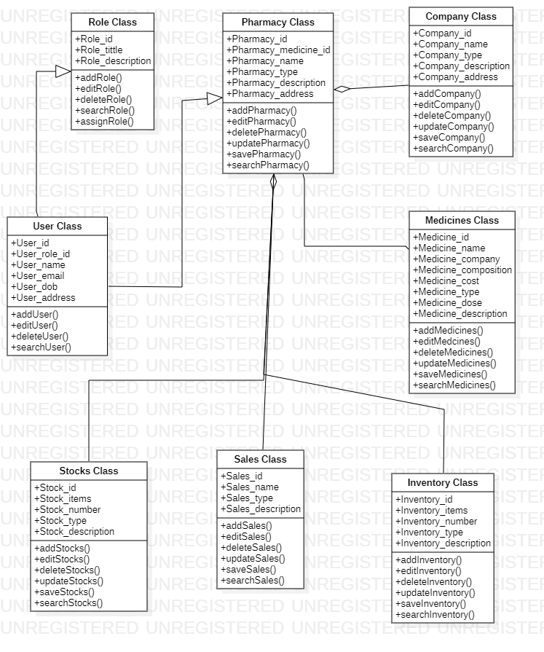

**ENTITY RELATION DIAGRAM (ERD)**

The entity relation diagram is used to represent the entities, attributes, and the relationship between each of table in the system. The ERD is the physical design of the database system and how it operates or function. The below diagram shows the ERD.

Below is the Entity Relation Diagram

**FIG. 4 ENTITY RELATION DIAGRAM**

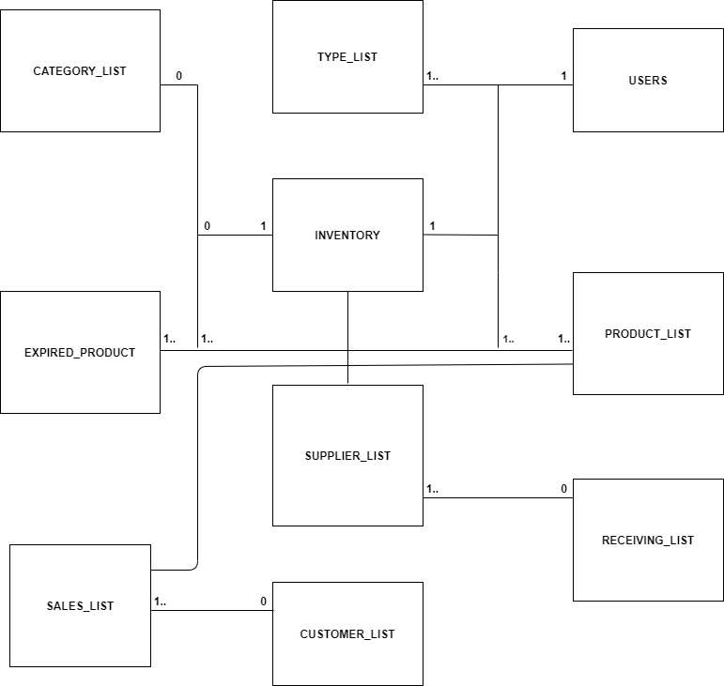

**BEHAVIORAL MODEL**

**ACTIVITY DIAGRAM**

The activity diagram is used to represent the various activities that goes on within the system and it shows the processes that occurs in the implementation of the system. The activity diagram shows the workflow of the system from the beginning to the end of the system operations. The diagram is shown below.

**FIG. 5 ACTIVITY DIAGRAM FOR THE ADMIN**

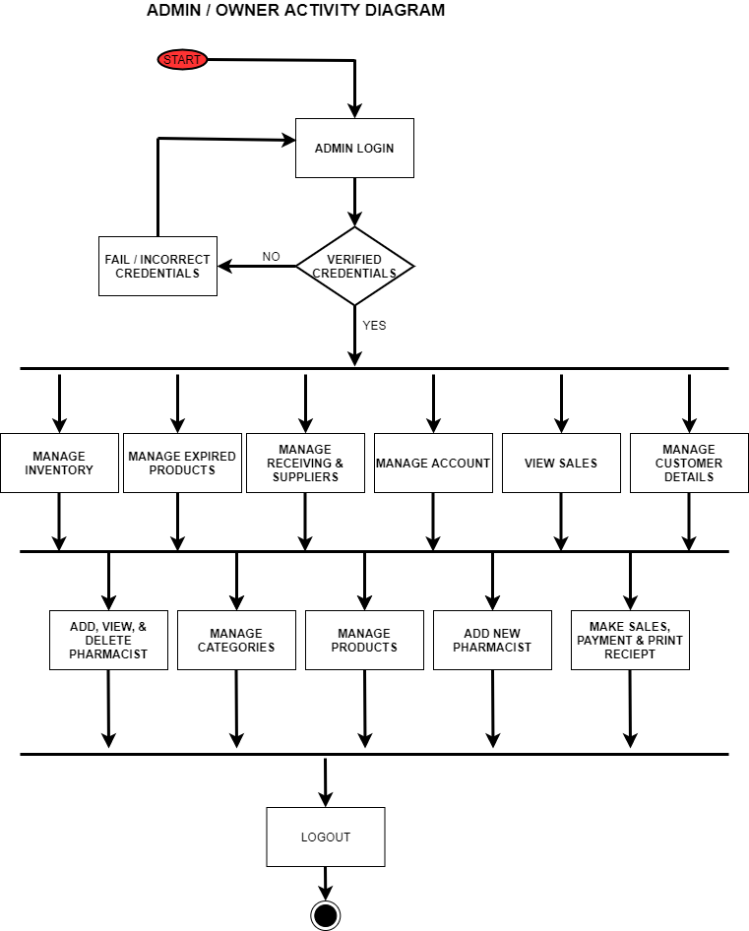

**FIG. 6 ACTIVITY DIAGRAM FOR PHARMACIST**

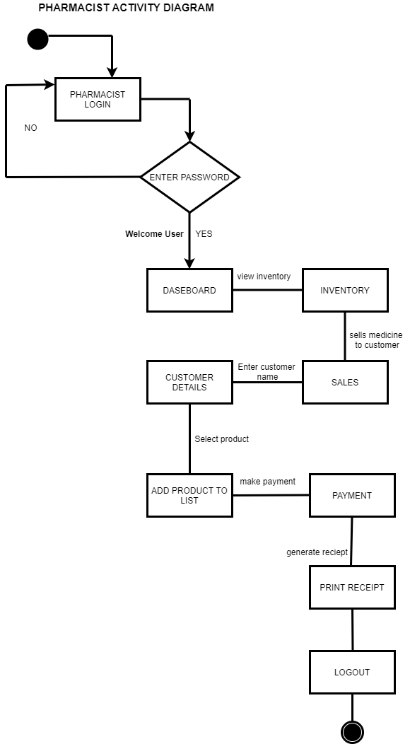

**JUSTIFICATION**

After a brief description of the above diagrams, I have decided to use the activity diagram as my choosing diagram because, as related to other diagrams such as the ERD and the Class diagram it too complex and it doesn’t show the kind of behavioral actions that goes on within the system but the activity diagram operate directly with the behavioral model of the system.

**SNIPPETS OF PROGRAMING CODES**

The script is for the admin information and data to be generated from the database and the login for both users of the system.

**FIG. 7 SCRIPT FOR THE LOGIN SECTION FOR BOTH USERS**

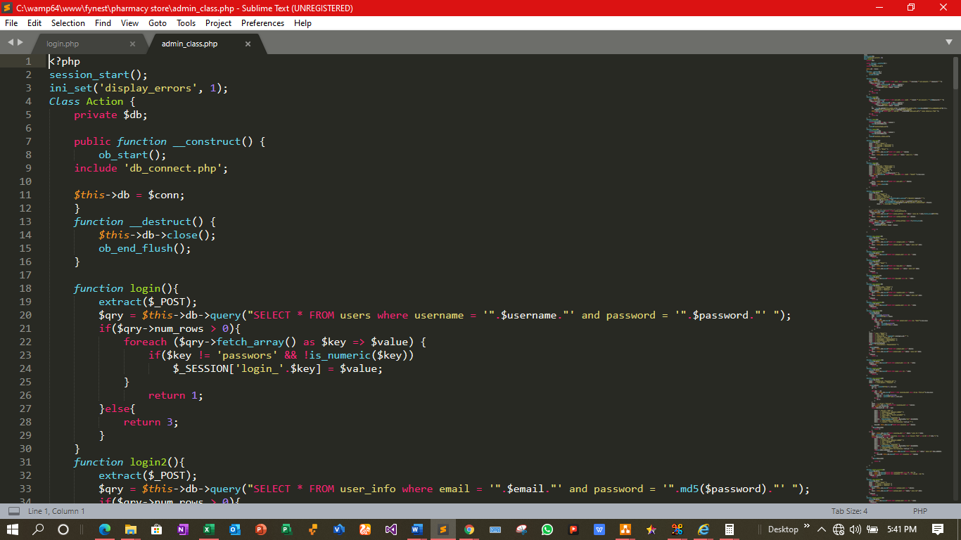

**FIG. 8 SCRIPT FOR THE SYSTEM SETTING**

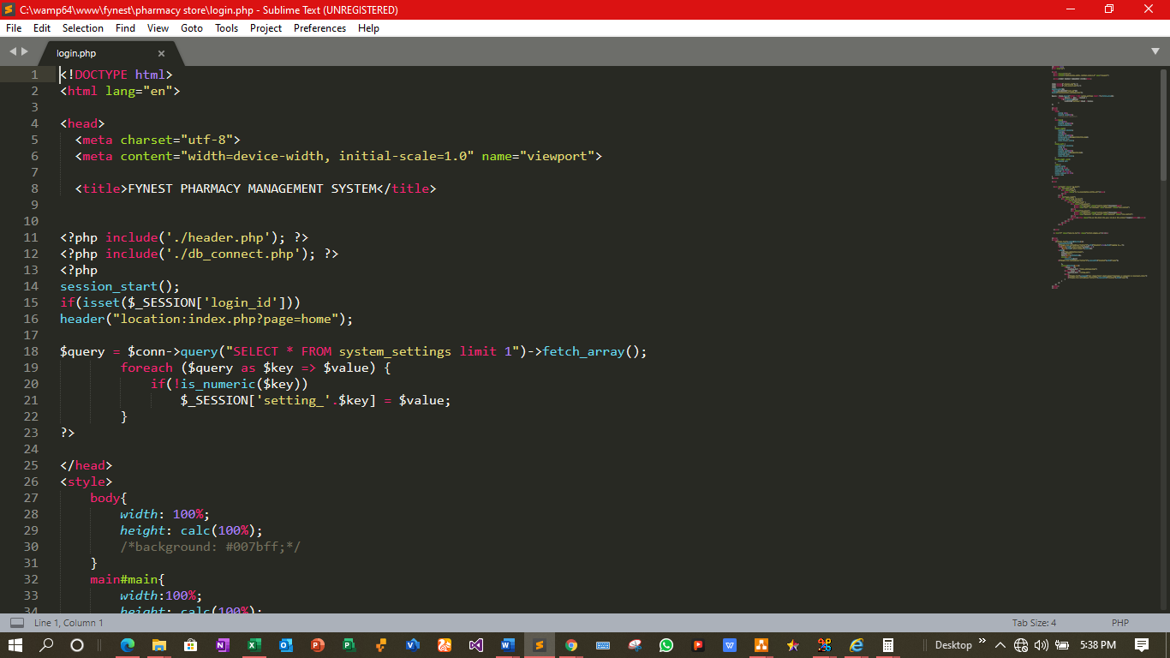

**SCREENSHOTS OF RELEVANT SECTIONS IN THE SYSTEM**

The admin dashboard after a successful login has be verified and log into the system.

**FIG. 9 ADMIN HOMEPAGE / DASHBOARD**

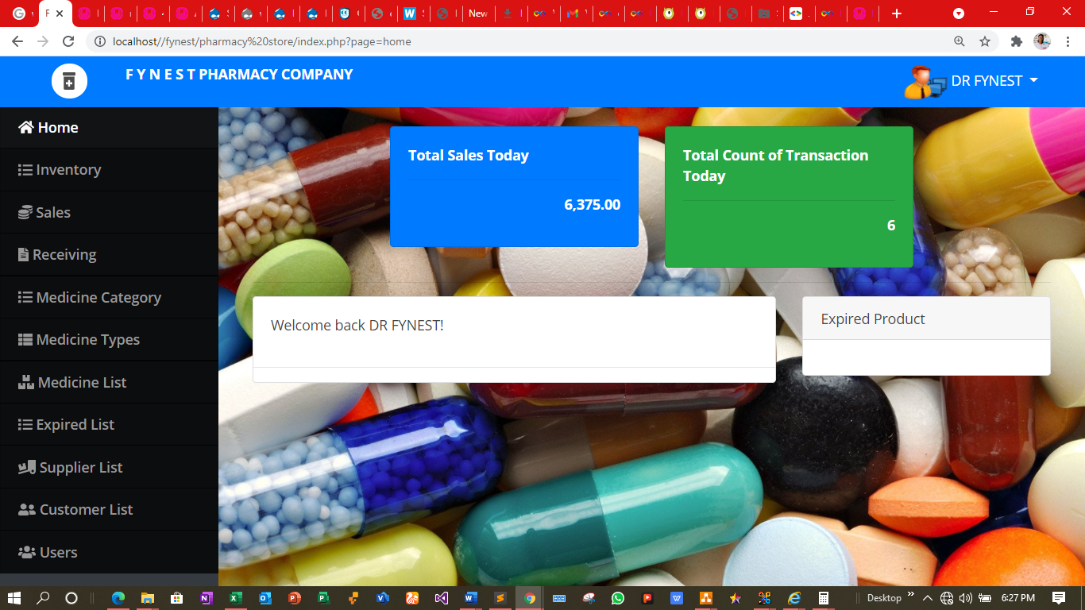

**FIG. 10 PHARMACIST DASHBOARD**

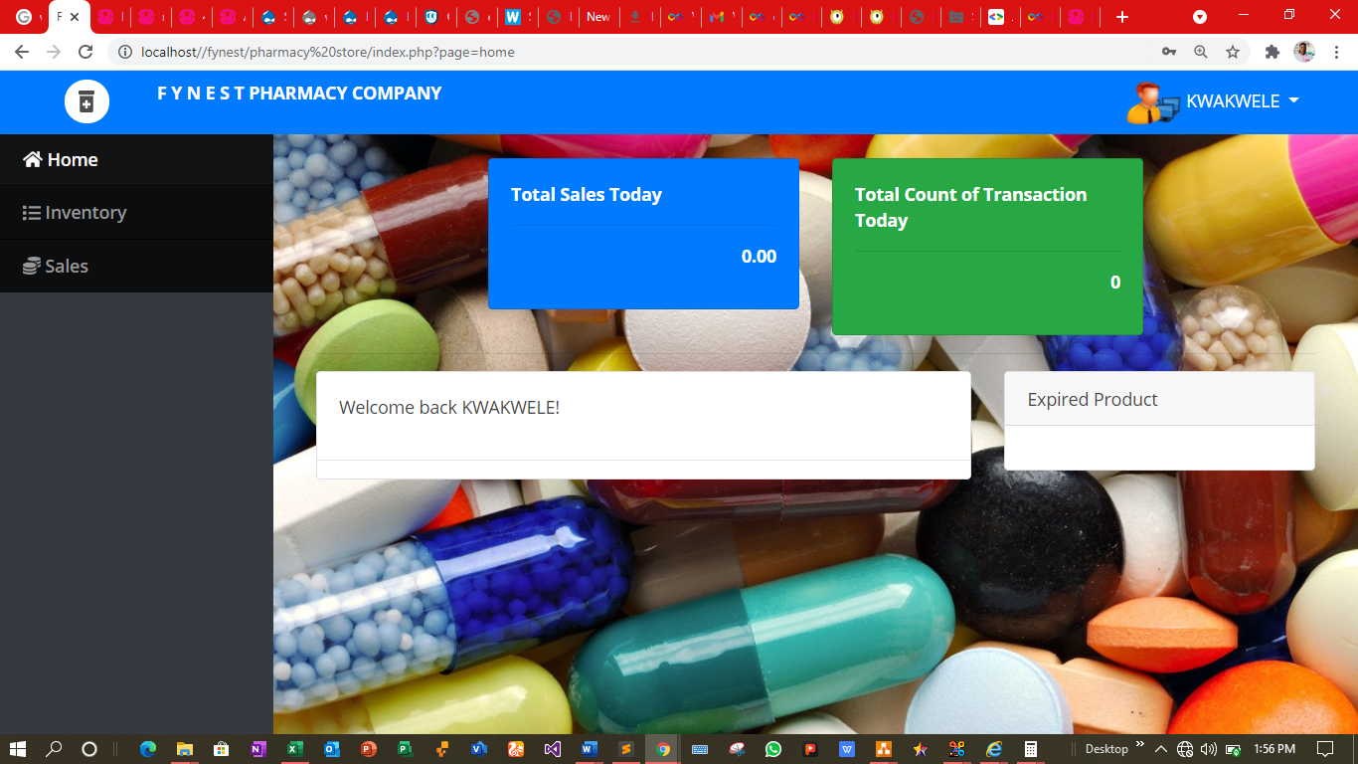

**FIG. 11 THE SALES SECTION**

This interface is the where the pharmacist will make sales for the customer

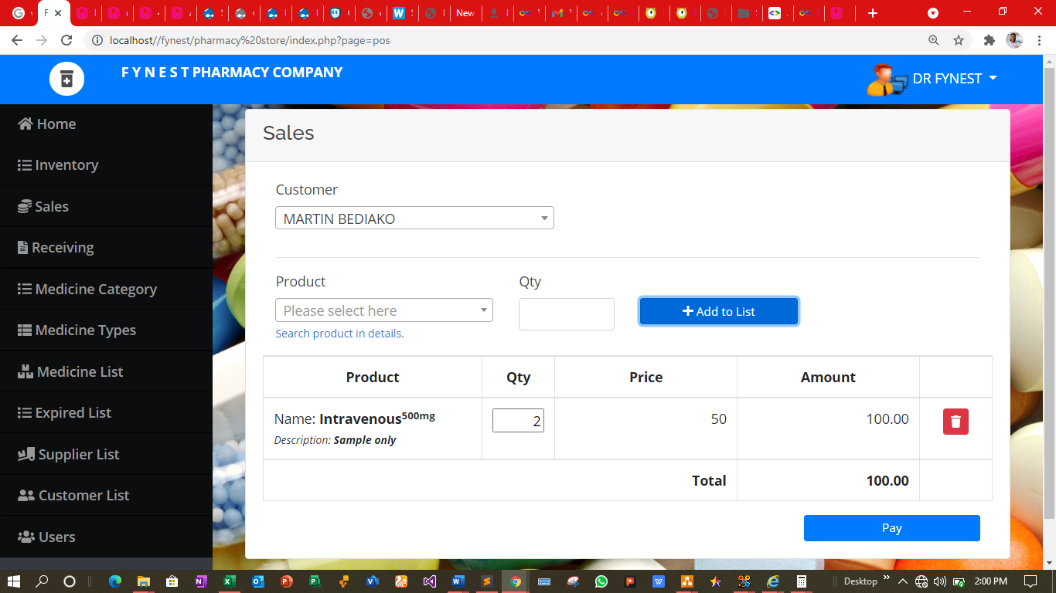

**FIG. 12 ADMIN PROFILE AND UPDATE**

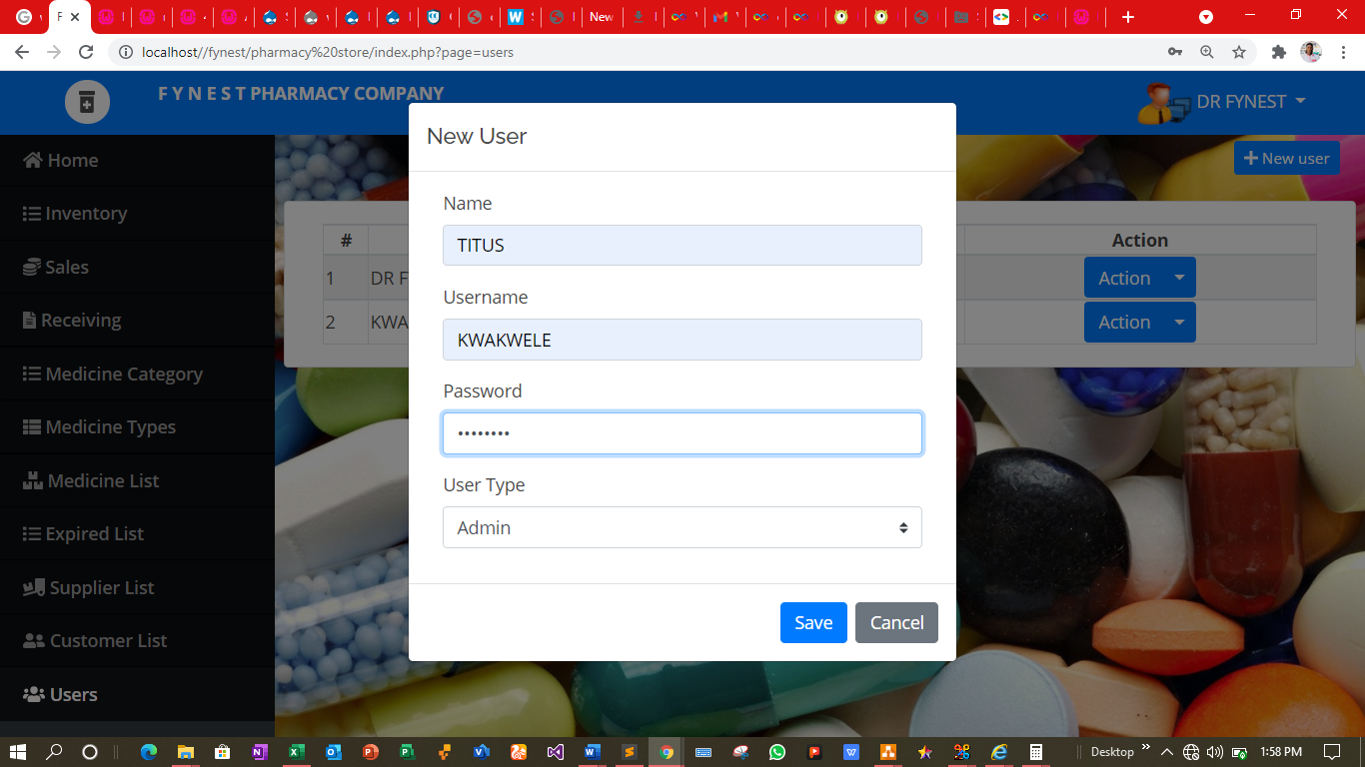

**FIG. 13 PRINT_SALES SECTION**

This snippet is the final print out receipt for the customer after all the purchasing process has been follow and applied.

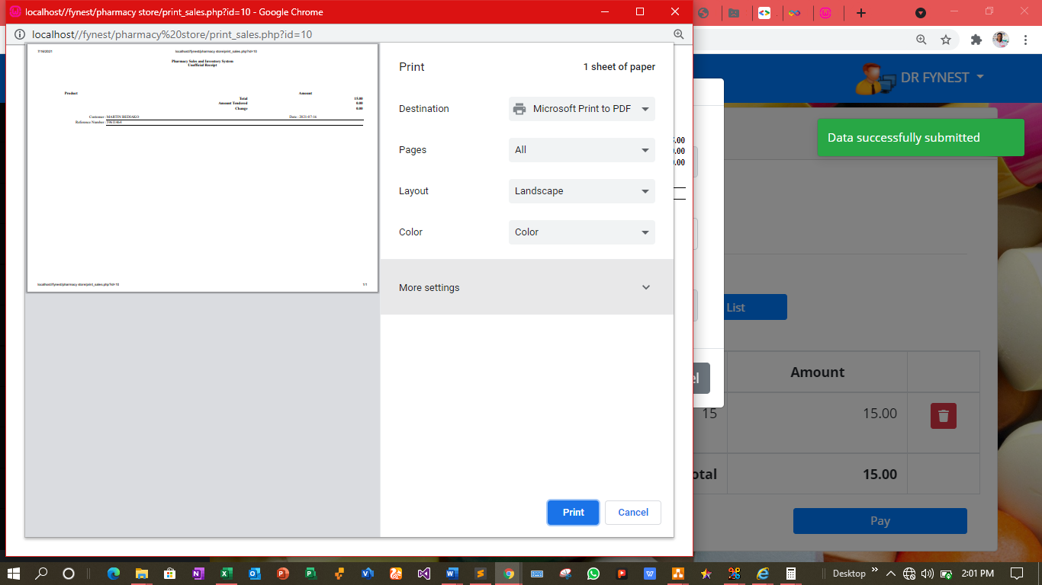

**CHAPTER 5**

**TESTING OF THE SYSTEM**

**Introduction**

This stage of the report is very important to the successful execution of the web application. This is the stage where all the functional requirements of the web application are being tested to errors conducted in the web application. Various kinds of testing will be thoroughly explained as well. The result or outcome of the tests can be used to determine if the proposed system developed is functioning well as expected.

**Types of testing**

* **REGRESSION TESTING**

This type of testing is being done after the modification of codes to make sure the system will function as expected. This testing is also being done to make sure that the system functions well with the new functionalities and previous executed tests are re-executed in order to verify the efficiency of change in the system.

* **USER-INTERFACE**

This type of testing involves testing the user interface of the system to ensure whether it was designed to meet the essential requirements of the user. This type of testing can help to make the system more user friendly in terms of its design model and images.

* **WHITE BOX TESTING**

This type of testing is performed by the development team because they are more knowledgeable about the system development and has basic understanding of the application codes, The testing also requires verification flow input or output to enhance design, usability and security of the system.

* **ALPHA TESTING**

Alpha testing is a software test that is being done before the beta testing and it’s been done to detect all errors in the whole system. This test is being done early on and near the final phase of software design.

* **BLACKBOX TESTING**

This is a type of testing that is being done to detect if all functionalities or specified requirements are met. This test analyzes the functionality of the web application without having much knowledge about its internal or design of the item being tested and separate the input value with the output value.

* **BETA-TESTING**

This testing is being done after the alpha testing. The beta version of the software is being released to users. The users evaluate the performance of the system and critics or feedbacks are being taken from that to improve upon the development of the system.

**LEVELS OF TESTING**

* **UNIT TESTING**

This is the type of testing that is being done on all the module of a system to ensure that the system functions as it is required to. This testing is usually done by programmers. The developer test to examine if there are any errors that he contributed to in the cost of developing the software and isolate each unit of the system to determine, analyzes and fix the errors.

* **INTEGRATION TESTING**

This is the second level of system testing. It involves the combination of all the system and isolating each part of the system to examine if the individual parts perform well in terms of requirements and functionalities.

* **SYSTEM TESTING**

At this level of testing, the entire testing is tested per the requirements. It is being done rigorously to examine if the system meets the specified standardized requirements stated and is being tested by the specialized testing team.

* **ACCEPTANCE SYSTEM**

This type testing is being done to ensure that the system meets or satisfy the user’s requirement. It is being done to determine if the user will interest in purchasing the system. There are also legal and contractual requirements stated and is being tested by the specialized testing team.

**TEST PLAN**

Below are some of the tests that were ran on the system. The test plan was generated from the functional requirements listed back in **chapter 3.**

|  |  |  |  |
| --- | --- | --- | --- |
| **FUNCTION TESTED** | **REASON FOR TESTING** | **EXPECTED OUTCOME** | **RESULTS** |
| Managing of products and supplies | To ensure the admin control the supply of products and also update the products list table. | Admin only has the authorized permission in managing the products and supply of medicines | Admin can successfully manage the products and supply of medicines after getting all the required information from the pharmacist. |
| Login | Certify if username and password credentials is accurate. | Users are only granted authorized access to the system if entered credentials tally with the records in the database. | Users are only qualified to login after entering the precise credentials. |
| Managing of Accounts | To ensure that the system allows the user to Add, update and delete customer records. | Customer records can be successfully added, updated and deleted by the user. | Only the users are allowed to add, update and delete customer records. |
| Edit or Update Personal details | To ensure that users of the system can edit or update their personal details without restrictions | Admin and Pharmacist can update their details without restrictions. Pop up a message if details is updated. | Admin and Pharmacist can update their details. A message is displayed to alert the user of that their details has been updated |
| Add new User | To ensure new users can be added. | Users must be added perfectly if the database doesn’t contain the user details. | Users can be added perfectly. When the pharmacist email or username already exist, a message will pop up to warn the admin. |
| Managing of Payments | To ensure that the customer payment details can be recorded in the system. | The Users of the system can check in every customer payment of products on the system., | Users can check in every customer payment of products and print them out as receipt. |

**TEST CASES**

|  |  |
| --- | --- |
| **FYNEST PHARMACY MANAGEMENT SYSTEM** | |
| **Course** | DCIT308 |
| **Created By:** | **Adeiy Jackson kofi 10903575**  **Mahama Abdul Hafiz - 10881447**  **Woolley Joseph Paul 10921657,**  **Agbeshie Dodzie-10907407**  **Owusu Abenkwan Benedict 10918803** |
| **Date Commenced** | **29/06/23** |
| **Date Accomplished** | **20/07/23** |
| **Performed By** | **Team Bolt** |
| **Test Environment** | **Google Chrome, Edge with the assist of WampServer.** |

**SCREENSHOTS**

**ADMIN AND PHARMACIST LOGIN PAGE**

**FIG. 14**

The login page for both the admin and the pharmacist before accessing the system.

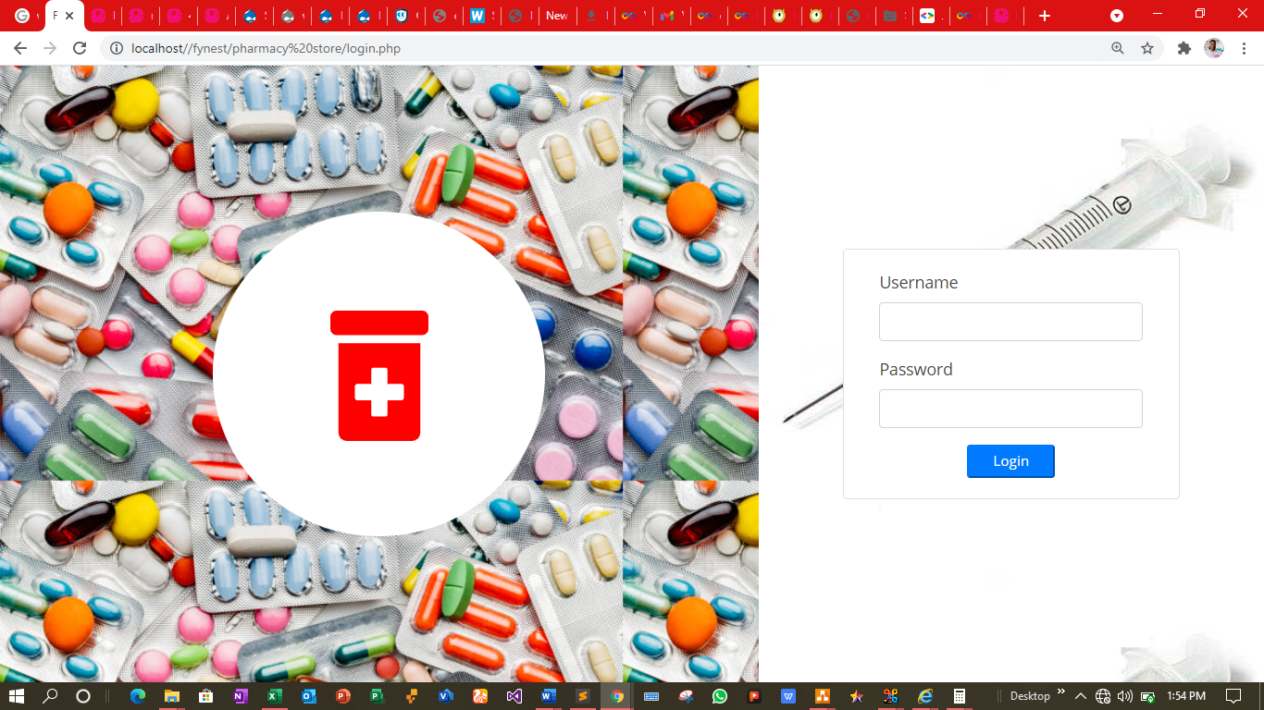

**Conclusion**

In this chapter of the report, I took my time carefully explore the system to test for errors and finalized to finally provide solutions to all errors conducted while developing the system. After that I also included screenshots to prove as an evidence that the system has been tested.

**CHAPTER 5**

**EVALUATION/ SOLUTIONS**

The pharmacist can now work in a systematic environment with alert warning process and managing stock in the pharmacy. Patients or customers will find it easy to get the information of the medicine through the internet. This can be useful alternative when there is emergency situation.

The system is more effective because analysis of all the total medicine sold can be recognize so that the company or owner can know the buying behavior of customers. In this case, pharmacist can make more order of the products been purchased more by customers.

This system also helps the pharmacist to produce medicine inscriptions or information to the customer. With this, customers get to know more about the product and the type of medicine to be purchased.

Report of sales and customer information are being stored and generated by the owner or the company every month or week to know the growth and development of the business.

**CONCLUSION**

Pharmacy management system is the only system that gives brief information of medicines, stock, sales and customer details. The problems that’s occurred are successfully determined to help the solution of the step-by-step modules included to be in the system.

The objectives will be achieved to help make the system function successfully. The objectives listed are the main core achievement of the system before other functions.

The scope of the system also gives the boundary to serve as a guide in the development of the system to reduce unnecessary process before it occurs. The scope of the application is divided as listed above and the developer will meet the necessary achievements with the limitations.

The solutions or output explains the advantages of the system when it is Implemented and will bring out a successful result to be achieved.

**APPENDIX PROPOSAL**

**CHAPTER 1**

**OVERVIEW**

**INTRODUCTION**

The FYNEST pharmacy management system is design and created to manage the sales and inventory, monitoring of available stock of the well-known medicine store in the country. This system is modified to help us in tracking expired product and also gives us notifications of the expiring date of the stock. And this will also check the amount of stock that a medicine product, that is expired and imputed into the system to deduct the number of stocks that is already for inventory monitoring and sales product available. The system is categorized by the list of medicines and types of medicine such as capsule, liquid, tablet, injection, etc. with this feature which helps the cashier or the sales manager to easily search and identifies the details of a requested medicine from which the customer is looking for, for example if a customer is looking for a 102g of Vitamin C +Zink, Selen medicine(ProLife) which is categorized in the group of medicine use for Healthy living but in this case, the pharmacy doesn’t have this product at that time, and this will help the pharmacist to search for another product in details to what the customer is looking for which will filter a product in the same similarity as said by the customer.

**JUSTIFICATION**

This is the reasons of developing the system to help reduce the work load of pharmacist and also helps to manage the day-to-day activities of the pharmacy. The reasons are stated below’

1. In recent times, selecting of medicine for customers takes time, so customer or patient must wait for some time.

1. Secondly, pharmacist has to check manually for the expiry date and the number of decrease medicine stock which are about to finish. So, this system helps in providing alert messages to warn the pharmacist about the medicine stock.
2. Finally, pharmacist will not find it difficult to make analyses of product purchased mostly by the customers in that area so as to supply more in the inventory stock list page for customer order and sales.

**DESCRIPTION OF PROPOSED SYSTEM**

The proposed system is basically based on the healthcare and the good health of the people in our community. The pharmacy in recent times operate manually pending down all the stock in books and doing paper work which can easily get missing or ton apart. The system gives massive support to the pharmacist and the growth of the pharmacy and health system in the country.

Due to bad operations, expired medicine is sold out without notification and alert to customers which brings health challenges to our people and this leads to sudden loss of human beings in the community or country.

**CHAPTER 2**

**AIMS, OBJECTIVES AND SCOPE**

**AIMS OF THE PROJECT**

The aim of this project is to examine the challenges faced by various pharmacies and how to develop a web base system that will provide solutions to the problems or challenges faced by the pharmacies. There are strategies put in place to resolve the problems at hand and give it a supporting guide line to promote the health care services.

**OBJECTIVES OF THE PROJECT**

The main objective of developing this system is to help in assisting pharmacist and other factors in our health care or environment. These factors or objectives are listed below.

1. To provide a well secure system software to help in retrieval of information
2. To provide stock exchange between the pharmacist and the suppliers.
3. To help in making decisions for the pharmacy.
4. To provide a systematic medicine inventory in stocking product
5. To manage the sales and report of the products in stock.

**SCOPE AND LIMITATIONS OF THE PROJECT**

The scope of the project is defined by the boundaries or limitations of the pharmacy management system which explains the system operations, functionalities, users and the features.

**FUNCTIONS OF THE SYSTEM**

These are the functionalities of the pharmacy management system

1. The system admin will put together all medicine and the same as the category of each medicine as well. This data is required by creating or adding new product in the medicine list which will be in categories of different medicines.
2. The system cannot be accessed by customers since it is operated manually by only the staff.

1. The admin will list the suppliers of the pharmacy who brings in medicine for sale. This will help the pharmacy to always track their stock from suppliers in receiving point.

1. Another function is based on the receiving feature which will be on the processing of stock system which is the first process before creating a transaction of sales. This will be done by the admin for the availability of the medicine in the system.
2. The system admin will fill in the list of customers in order to track sales of transactions and track the customer or client that have bought the medicine from the pharmacy. This function is optional for the pharmacist in a way that a customer can be classified as guest in the system.
3. The system will brief or notify the pharmacist about products which are about to expire or in the range of expiring.

1. The system brings information of medicine prescribe to customers when searched in the search button.

1. The system admin will be able to add users or sales personnel into the system and also check their day-to-day activities or sales in the pharmacy.
2. The admin will be able to track the inventory or number of stock product in the pharmacy.
3. After the admin is done in putting in place all the list mention above, the pharmacist or the admin can start using the sales feature of the system.

**LIMITATIONS**

1. Customers cannot make direct payment through the system but it can be made by the pharmacist by giving out cash for your product purchase.
2. The sales section cannot be updated or deleted since there is limitation of sales made in a day by pharmacist.
3. The system doesn’t contain any backup database since it can be done mainly by the admin or pharmacist.
4. The system doesn’t support all kinds of payment except cash related payment issue directly to the pharmacist.

**KEY ACTIVITIES**

**GATHERING OF INFORMATION**

This activity deals with the researching of various information for the development of the system. It requires the gathering of key information about the functions and overview of the whole system.

**RESEARCH METHODOLOGIES**

This activity is main based on the type of research methodologies used in developing the system which comes with the prescribe or suitable for the system.

**CHOOSING OR SELECTING OF SCRIPT LANGUAGES**

The script language is the main codes which help the system to function well and also communicate to each language on the web server. The best suitable languages are selected for the system.

**CODING OF THE SYSTEM**

This is where the system is being develop with the front-end and back-end language such as HTML, CSS, PHP and JAVASCRIPT with MYSQL.

**TESTING OF THE SYSTEM**

This activity is where the system is being tested and work correctly without any errors in performing its functions and meets all the requirements.